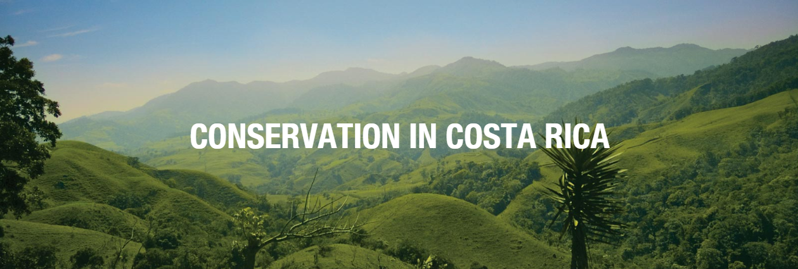

Dear Parents/Guardians,

I am pleased to announce that a group of students and educators from our community will be visiting beautiful Costa Rica for an educational tour in the summer of 2019! This is a once-in-a-lifetime experience that will truly set your child apart!

Your student has been recommended for this experience is being personally invited to take advantage of this opportunity. There is limited space left on the trip so our upcoming meeting is mandatory for all those interested in traveling.

I am holding the informational meeting on October 30th at 6:30pm at the Brace Family YMCA where I will cover all the details of the trip. I hope to see you there!

Warm regards,
Andrea Wise

Please RSVP by October 29th!
https://conservationcostaricatrip2019.eventbrite.com

